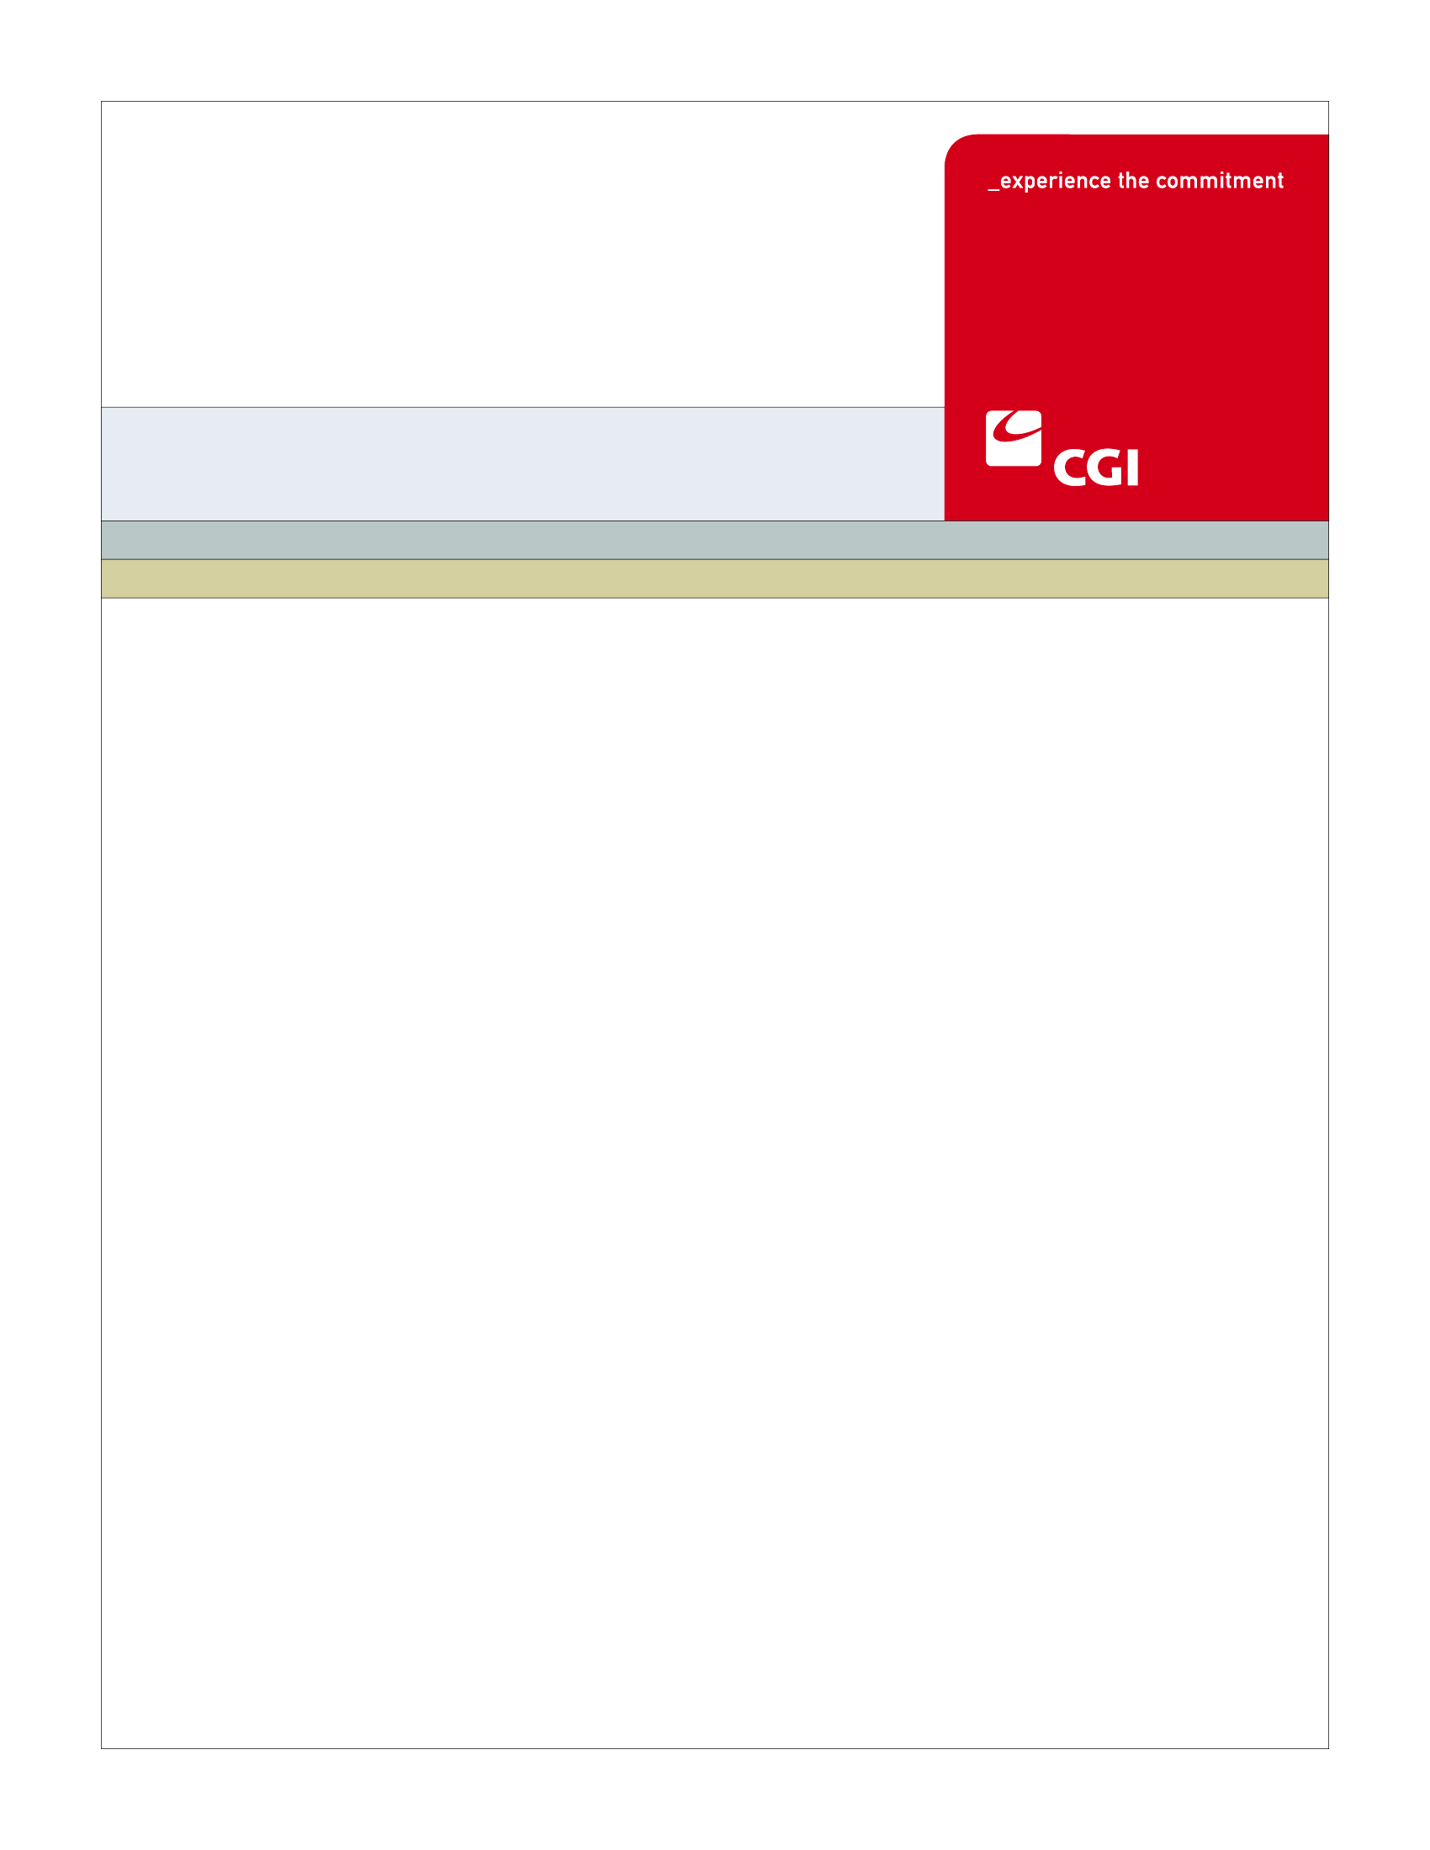USE

**BN-003**

**Maintain Book of Business**

**Use Case**

**Colorado Health Benefit Exchange (COHBE)**

**Version 2.0**

**November 12, 2012**

REVISION HISTORY

|  |  |  |  |
| --- | --- | --- | --- |
| Version | Date | Modified By | Description |
| 0.1 | 10/14/2012 | Derek Sullivan | Initial Draft |
| 0.2 | 10/22/2012 | Derek Sullivan | Discovery Session Updates |
| 0.3 | 10/22/2012 | Derek Sullivan | Elaboration Session Updates |
| 1.1 | 11/05/2012 | Derek Sullivan | Verification Session Updates |
| 2.0 | 11/12/2012 | Derek Sullivan | Approved Version |
|  |  |  |  |
|  |  |  |  |
|  |  |  |  |
|  |  |  |  |
|  |  |  |  |
|  |  |  |  |
|  |  |  |  |
|  |  |  |  |
|  |  |  |  |

TABLE OF CONTENTS

1 Use Case: Maintain Book of Business 6

1.1 Goal 6

1.2 Brief Description 6

1.3 Requirements Traceability 6

1.4 Primary Actor 6

1.4.1 Broker 6

1.5 Secondary Actor 7

1.5.1 Employer 7

1.5.2 Individual 7

1.5.3 Exchange 7

1.6 Pre-Conditions 7

1.7 Successful Post-Conditions 7

1.8 Triggers 7

1.9 Assumptions 7

2 Flow of Events 9

2.1 Basic (Main) Flow – Maintain Book of Business 9

2.1.1 View Book of Business 9

2.1.2 Upload Client Files 10

2.1.3 Client Comments 10

2.1.4 Establish Prospective Client 10

2.1.5 Provides Broker of Record Letter 10

2.1.6 Receives Broker of Record Letter 10

2.1.7 Does Client Grant Broker of Record? 10

2.1.8 Receives Signed Broker of Record Letter 10

2.1.9 Update Client to Client Status 11

2.1.10 Is this Information Correct? 11

2.1.11 Does Client Want to Continue Relationship? 11

2.1.12 Download Book of Business to an Excel File 11

2.1.13 Book of Business 11

2.1.14 Next Steps 11

3 Alternate Flows 13

3.1 Create Proposal Alternate Flow 13

3.1.1 Create Proposal 13

4 Exception Flows 14

4.1 No Sale Exception Flow 14

4.1.1 Update Client to No Sale Status 14

4.2 Ex-Client Exception Flow 14

4.2.1 Update Client to Ex-Client Status 14

4.2.2 Remove Broker Commission 14

4.2.3 Update Client Account 14

4.3 Inactive Client Flow 14

4.3.1 Update Client to Inactive Status 14

5 Specifications 15

5.1 Business Rules 15

5.2 Process Rules 15

5.3 Workflow 15

5.4 UI Screen Details 15

5.4.1 UI Flow Considerations 15

5.4.2 View Book of Business 15

5.5 Communications 15

5.5.1 Imaging Requirements 15

5.5.2 Form Requirements 15

5.5.3 Notice Requirements 16

5.5.4 Other Communication Requirements 16

5.6 Interfaces 16

5.7 Reporting 16

5.7.1 User Experience 16

5.7.2 Business Activity 16

5.7.3 Workflow 16

5.7.4 Community and Public Health 16

5.8 User Security 16

5.8.1 Actor Status Changes 16

5.8.2 Sensitive Information/Data 17

5.8.3 Data Transmission Requirements 17

5.9 Activity Log and Audit Trail 17

No updates at this time. 17

5.10 Data Elements 18

6 Future Release Notes 20

Appendix A - Glossary 20

# Use Case: Maintain Book of Business

## Goal

The goal of this Use Case is to allow a Broker to view and maintain their current and prospective clients.

This Use Case completes succesfully when a Broker is able to view and maintain current and prospective clients on the Broker Portal.

## Brief Description

A Broker maintains a list of prospective and current clients. The Broker is able to manage client lists and track proposals.

## Requirements Traceability

The following requirements are covered within this Use Case:

* SH100: The System shall provide Brokers with an individual homepage to view current client activities and to access broker quote and contact management tools.
* SH120: The System shall provide the capabilities of displaying a Broker's book of business.
* SH122: The System shall provide Brokers with the ability to upload files to the Exchange. These files will contain the Broker’s current clients, contact details, coverage, preferences, etc.
* SH131: The System shall provide the ability to download a Broker's book of business into an excel spreadsheet.

## Primary Actor

### Broker

The Broker views and maintains a list of current and prospective clients.

## Secondary Actor

### Employer

If required, the Employer will provide additional supporting materials.

### Individual

If required, the Individual will provide additional supporting materials.

### Exchange

The Exchange will update and store the Broker’s Book of Business.

## Pre-Conditions

* The Broker must be certified via the Certify Broker Use Case.

## Successful Post-Conditions

* The Broker may have updated prospective or existing clients.
* The Broker may have received a signed Broker of Record letter.
* The Broker may have created proposals for new or existing clients.

## Triggers

* A Broker needs to establish or update a prospective client, current client or ex-client.
* A Broker receives notification that they have been authorized by a client.
* A Broker receives notification that they have been de-authorized by a client.

## Assumptions

* Authority to Purchase will be handled in the Create Proposal Use Case.
* Uploading and downloading client files will be optional but must be a specific file format.
* This Use Case is used to add to as well as maintain the Book of Business.
* Brokers are only allowed to access client accounts if they have been supplied a Broker of Record letter.
* Brokers will not be provided with any tools to prospect for existing Exchange accounts.
* Authorizing a Broker in the Select Broker Use Case is sufficient for Broker of Record.
* Brokers are only using this Use Case for Exchange related business activity.

# Flow of Events

The Business Process Activity diagram below shows the COHBE processes for the Maintain Book of Business Use Case. The steps numbered on the diagram below have detailed explanations in the sections that follow.



## Basic (Main) Flow – Maintain Book of Business

A Broker, after creating its account in the Exchange, can view, upload or download a list of current and prospective clients. If it is a prospective client, the Broker will provide the Client with a Proposal and then a Broker of Record letter. Once signed and returned, the Broker may perform business activities on behalf of the Client. If it is an existing client, the Broker will create a proposal for the current client.

### View Book of Business

The Broker, after logging in to their account on the Exchange, views their Book of Business.

### Upload Client Files

The Broker may upload client files. These files will contain the Broker’s current clients, contact details, coverage, preferences, etc.

### Client Comments

The Broker enters comments to manage contacts (Prospect, Client, Ex-Client, Inactive, No Sale) based on comment type. The various comments may include:

* Policy Notes
* Client Notes
* Maintenance Notes

### Establish Prospective Client

The Broker updates the Client to Prospect Status in their Book of Business and may begin to anonymously shop to create proposals for the prospective client.

### Provides Broker of Record Letter

The Broker will provide a prospective client with a Broker of Record letter. This will authorize the Broker to act on the Clients behalf up to the point of purchasing insurance on the Exchange.

### Receives Broker of Record Letter

The prospective client receives and reviews the Broker of Record letter.

### Does Client Grant Broker of Record?

The client must decide if they would like to allow the Broker to perform business on their behalf.

### Receives Signed Broker of Record Letter

The client signs the Broker of Record letter and returns it to the Broker. This can be an electronic or paper form that the Broker can upload into the Exchange if requested by the Exchange to do so. If this was accomplished electronically an Email notification will be sent to the Broker (See Section 5.5.3.1).

### Update Client to Client Status

After receiving the signed Broker of Record letter, the Broker will update the Client from Prospect to Client status in their Book of Business. The Broker will enter the login ID and last name on the account to verify they are updating the correct client.

### Is this Information Correct?

Upon entering the login ID and last name, the Exchange will return:

* First Name
* Last Name
* Address

If this information is incorrect the Broker must repeat Step 2.1.8 and enter the correct information.

### Does Client Want to Continue Relationship?

At any time the Client may decide whether or not to continue working with the same Broker.

### Download Book of Business to an Excel File

The Broker may download their Book of Business into an Excel spreadsheet.

### Book of Business

The Exchange will store and save any updates to the Broker’s Book of Business files.

### Next Steps

Based on information that was updated, the user can proceed to various next steps, such as:

* Manage Employee Roster
* Select Plans and Determine Contribution
* Appeal Employee APTC
* Appeal Employer Eligibility
* Create Employer/Individual Account
* Select Broker Use Case to authorize Broker
* Manage Employer Information
* Manage Individual Information

# Alternate Flows

## Create Proposal Alternate Flow

### Create Proposal

This alternate flow will be handled by the Create Proposal Use Case.

# Exception Flows

## No Sale Exception Flow

### Update Client to No Sale Status

If the Client does not grant a Broker of Record letter, then the Broker will update the Client to No Sale status in the Book of Business.

## Ex-Client Exception Flow

### Update Client to Ex-Client Status

If the Client chooses to sever the relationship with the Broker or leaves the Exchange, the Broker will update the Client’s status to Ex-Client in the Book of Business.

### Remove Broker Commission

When a Broker changes a client’s status to Ex-Client the Exchange will remove the Broker commission relationship with the Ex-Client.

### Update Client Account

The system updates the Client’s account to reflect the de-authorization of the current Broker

## Inactive Client Flow

### Update Client to Inactive Status

If the Client becomes inactive and the Broker is still receiving commission, the Broker will update their status to inactive.

# Specifications

## Business Rules

There are no Business Rules for the Maintain Book of Business Use Case.

## Process Rules

There are no Process Rules for the Maintain Book of Business Use Case.

## Workflow

There are no Workflows for the Maintain Book of Business Use Case.

## UI Screen Details

### UI Flow Considerations

There are no UI Flow Considerations for the Maintain Book of Business.

### View Book of Business

See Section 5.10 for list of fields.

## Communications

### Imaging Requirements

The Broker will have the ability to scan and upload the Broker of Record letter to their Broker Portal account.

### Form Requirements

The Broker of Record letter is a Form Requirement.

### Notice Requirements

#### Broker of Record Notification

#### An email notification will be sent to the Broker stating the Client has granted Broker of Record.

### Other Communication Requirements

There are no Other Communication Requirements for this Use Case.

## Interfaces

There are no Interfaces for the Maintain Book of Business Use Case.

## Reporting

### User Experience

Report on click screen monitoring (how often screens are being used).

### Business Activity

Report on failed Client linking attempts, to detect Broker prospecting attempts.

Report on Individuals contacting the call center that are linked to specific Brokers.

Report on Brokers with a high turnover (several ex-clients, etc.).

### Workflow

There are no Reporting on Workflow requirements for this Use Case.

### Community and Public Health

There are no Reporting on Community and Public Health requirements for this Use Case.

## User Security

### Actor Status Changes

* If a Prospective Client Status has changed to a Client Status, the Broker is self-attesting to having a Broker of Record letter from the Client.

### Sensitive Information/Data

* Additional security precautions may be needed when a client’s file is uploaded.
* Prospective client data must be handled appropriately.

### Data Transmission Requirements

* Any uploaded information will be handled by the security architecture team.

## Activity Log and Audit Trail

### No updates at this time.

## Data Elements

| Process Step Reference  **\*Required Field** | Field Name  **\*Required Field** | Required Field? | Action Taken | Actor Performing Action | Format, if known |
| --- | --- | --- | --- | --- | --- |
| 2.1.1 | Client Type | * Required | * Create,Modify,Delete | * User | * Individual or SHOP Employer(dropdown defaulted to Individual) |
| 2.1.1 | Company Name | * Optional | * Create,Modify,Delete | * User |  |
| 2.1.1 | DBA | * Optional | * Create,Modify,Delete | * User |  |
| 2.1.1 | Client Address | * Required | * Create,Modify,Delete | * User |  |
| 2.1.1 | City/County | * Required | * Create,Modify,Delete | * User |  |
| 2.1.1 | State | * Required | * Create,Modify,Delete | * User |  |
| 2.1.1 | Zip Code | * Required | * Create,Modify,Delete | * User |  |
| 2.1.1 | Last Modified | * Required | * Create,Modify,Delete | * Exchange System |  |
| 2.1.1 | NAICS | * Optional | * Create,Modify,Delete | * User |  |
| 2.1.1 | Federal ID | * Optional | * Create,Modify,Delete | * User |  |
| 2.1.1 | Lead Source | * Optional | * Create,Modify,Delete | * User |  |
| 2.1.1 | Status | * Required | * Create,Modify,Delete | * User | * List Values for Status may include: Prospect, Client, Ex-Client, Inactive, No Sale |
| 2.1.1 | Number of Employees | * Optional | * Create,Modify,Delete | * User |  |
| 2.1.1 | Correspondence To | * Optional | * Create,Modify,Delete | * User |  |
| 2.1.1 | Contact  (First Name, Last Name) | * Optional | * Create,Modify,Delete | * User |  |
| 2.1.1 | Contact  Job Title | * Optional | * Create,Modify,Delete | * User |  |
| 2.1.1 | Contact  Work Phone | * Optional | * Create,Modify,Delete | * User |  |
| 2.1.1 | Comments | * Optional | * Create,Modify,Delete | * User |  |
| 2.1.1 | Policy # | * Optional | * View | * User |  |
| 2.1.1 | Policy  Effective Date | * Optional | * View | * User |  |
| 2.1.1 | Policy  Renewal Date | * Optional | * View | * User |  |
| 2.1.1 | Policy  Premium | * Optional | * View | * User |  |
| 2.1.1 | Policy  Mode | * Optional | * View | * User |  |
| 2.1.1 | Policy  Product | * Optional | * View | * User |  |
| 2.1.1 | Policy  Type | * Optional | * View | * User |  |
| 2.1.1 | Policy  Carrier | * Optional | * View | * User |  |
| 2.1.1 | Policy  Face Amount | * Optional | * View | * User |  |

# Future Release Notes

CR #76 The System should provide brokers the ability to view policy renewals that are upcoming 30, 60 and 90 days in advance.

# Appendix A - Glossary

| Term | Definition |
| --- | --- |
| ***Account*** | An “Account” is the means by which a user can access a computer system |
| ***Activity Log*** | An “Activity Log” is a chronological record of every action taken by each user, and by the System on behalf of each user.  The activity log includes actions and events pertaining to transactions, workflow, security (including SIEM), Alerts, Notifications, Approvals and interactions between the user and the System such as submissions of forms, data and documents. |
| ***Alternative (process path)*** | An “alternative” is one subset of many steps within a process that achieve the same result or process end state. |
| ***Anonymous Shopping*** | “Anonymous Shopping” means the ability for a Customer to review health plans that are available to him or her without revealing personally identifiable information. Information needed to Anonymously Shop is very limited. |
| ***Audit Trail*** | An “Audit Trail” is a subset of records in the Activity Log that are selected and correlated by criteria provided by the auditor or requesting authority. |
| ***Brokers*** | “Brokers” are persons certified to assist Employers and or Individuals in their activities to shop for insurance through the Exchanges. |
| ***Broker of Record Letter*** | A “Broker of Record Letter” allows a Broker to be designated by the policy holder to represent and manage the policyholder's insurance policy. The broker of record may receive copies of all communications to the policy holder and may receive all quotes, policies and notices on behalf of the policy holder. They may also obtain and evaluate insurance quotes and policies and recommend changes to existing policies. |
| ***Certification*** | “Certification” is a determination by COHBE or other government-authorized entity that an action or object complies with policy and may proceed or be used. |
| ***Client Status*** | When a prospective client grants broker of record, the Broker will update the client to “Client Status” in their book of business. |
| ***Employer*** | An “Employer” is a company or small business who participates in the Exchange to offer insurance and/or premium assistance to its Employee(s) or its Employee(s) and their dependents. |
| ***Exception*** | “Exception” shall mean either:  • a deviation from prescribed workflow, process, status, rule or circumstance or  • A pre-defined condition that requires additional, pre-defined action or intervention to conform to business rules and return to the main process when resolved; depending on context. |
| ***Exchange*** | During the implementation phase, the terms “Exchange” or “Exchanges” are meant to include technology, services, business processes, people, and other resources required to implement, operate and/or maintain the requirements or functions needed to support the ability for consumers to shop for and purchase health insurance. Specifically related to interpretation of a requirement, the term “Exchange” implies that the implementation of a requirement is not strictly limited to a technology solution.  • Individually, the term “Exchange” refers to each Exchange or both Exchanges as appropriate in the context.  • The Exchange is NOT a state agency but a standalone non-profit entity. It will serve as an aggregator of individual policies sold by private insurers and underwritten using the new federal and state underwriting and rating rules.  • The Small Business Health Options Program (SHOP) Exchange will support the specific needs of small employers.  • For context, the Exchanges will act much like an “Expedia or Orbitz for Health Insurance” system. They will allow individuals and small firms to obtain information, compare and purchase private health insurance plans. The Exchanges will also be the entities that will evaluate whether or not a particular insurance policy meets the criteria set out by the new federal rules for policies offered to individuals and small employers. |
| ***Ex-Client Status*** | When a client chooses to sever the relationship with a Broker or leave the Exchange, the Broker will update the client to “Ex-Client Status” in their book of business. |
| ***Inactive Status*** | When a client’s account is lacking activity; lying idle or not being actively worked by the Broker, the Broker will update the client to “Inactive Status” in their book of business. |
| ***Individual*** | “Individual” is generally meant to identify a person who obtains insurance for themselves and/or their dependents through the Individual Exchange. |
| ***No Sale Status*** | When a client does not grant broker of record, the Broker will update the client to “No Sale Status” in their book of business. |
| ***Prospect Status*** | When a potential or likely client communicates with a Broker, the Broker will update the client to a “Prospect Status” in their book of business. |
| ***Self-Attested Data*** | “Self-Attested Data” is information provided by a consumer that has not been validated by COHBE or other government system. The Exchange will develop a process to validate Self-Attested data. Once validated, Self-Attested data will override any system-provided data (e.g., income, citizenship status). |